Lab No. 05

CPU Scheduling (Preemptive Algorithms)

|  |  |
| --- | --- |
| Lab Objectives | Following are the lab objectives:   1. Implement Priority Scheduling Algorithm 2. Implement Highest Response Ratio Next (HRRN) Algorithm |

|  |  |  |  |  |  |  |
| --- | --- | --- | --- | --- | --- | --- |
| **Roll No.** | **3370** | **Student Name** | | **Mudassar Hassan** | | |
|  | **Marks** |  | **Obtained Marks** |  | **Comments** | |
| **Task 1** | **20** |  |  | |
| **Task 2** | **20** |  |  | |
| **Total Marks** | **40** |  |  | |
|  |  | | | | |  |
| **Lab Instructor** | | | | | |
|  | | | | | |

**Lab Tasks**

**Task 1 (20 marks)**

Write C++ program to simulate **Priority Scheduling** algorithm to manage processes. For process representation **struct process** must be used. All processes should be stored to the ready queue with proper information (burst time, arrival time, etc.). Later on display the **process ID, burst time, wait time, turnaround time, average wait time and average turnaround time**.

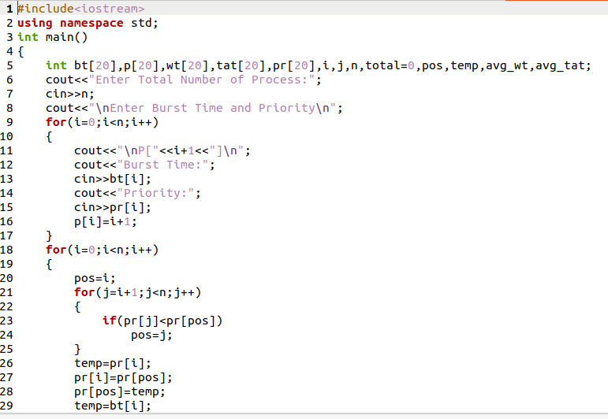

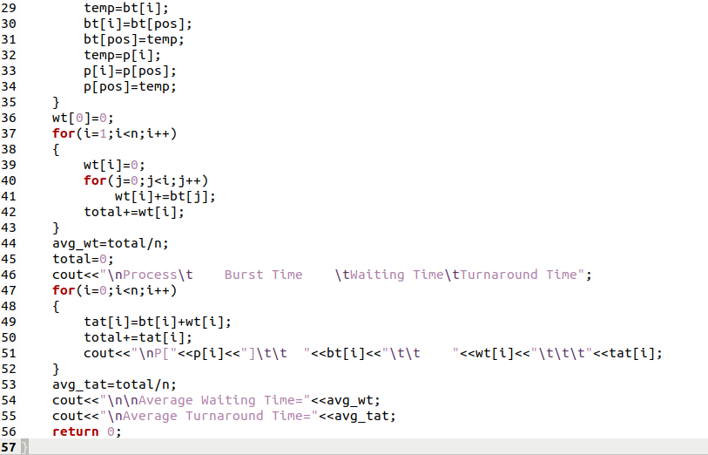

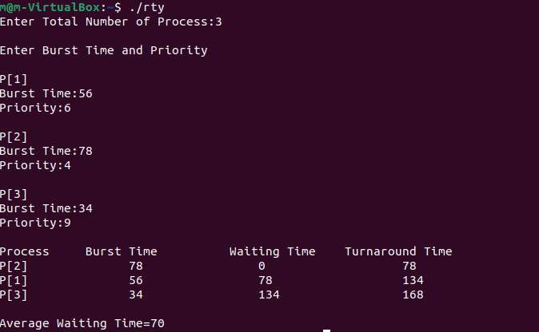

**Task 2 (20 marks)**

Write C++ program to simulate **Highest Response Ratio Next (HRRN)** algorithm to manage processes. For process representation **struct process** must be used. All processes should be stored to the ready queue with proper information (burst time, arrival time, etc.). Later on display the **process ID, burst time, wait time, turnaround time, average wait time and average turnaround time**.

